**CPS My Tomorrow Mobile App Documentation**

Table of Contents

Mobile application -Architecture: 3

Architecture flow of Mobile (Native Apps): 3

Architecture flow of the .NET Web application: 3

Architecture flow of Drupal Web application: 3

Web Service (.NET Web API): 3

Database Schema Structure and Relations: 4

1. Mobile App: 4

Logging in: 4

Themes 5

Student Login 7

Home Page: 7

Search: 10

Notifications: 11

Menu: 12

LeaderBoards: 13

Rewards System: 15

Hall Passes: 15

Suggestion Box: 17

Digital Binder: 18

Calendar: 20

Profile: 22

Opportunities: 23

Help: 24

Teacher Login 25

Home: 25

Notifications: 29

Menu: 30

LeaderBoards: 31

Rewards System: 32

Hall Passes: 32

Suggestion Box: 33

Digital Binder: 34

Calendar: 36

Profile: 38

Help: 38

# Mobile application -Architecture:

The Cincinnati Public Schools (CPS) application is accessible via mobile developed in Android, iOS and web application developed using Microsoft .NET for student or teacher and an admin site, that was developed using Drupal Content Management System (CMS). The Web API services calls are developed in C# and is consumed in each of the mobile, web and admin sites.

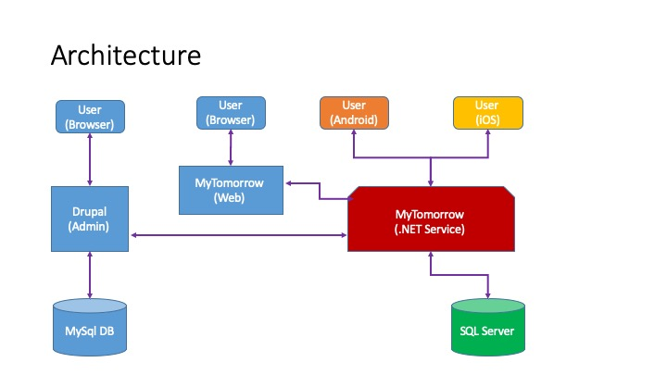

## Architecture flow of Mobile (Native Apps):

The mobile application follows the Model-View-Controller (MVC) pattern in both Android and iOS versions. It contains service, interfaces and classes required to perform different tasks in the mobile application.

There are two different projects for Android and iOS which are developed using Java programming and Swift.

## Architecture flow of the .NET Web application:

We are using .NET Model View Controller (MVC) pattern for the web application. MVC is a three-layer development architecture used for web application development. The Model includes all the data and its related logic, the View presents data to the user or handles user interaction and the Controller acts as an interface between the Model and View components.

We are using Google OAuth Authorization for user login and using .NET API service calls as the intermediate between web and mobile application and the database. Web API call services will take care of all the data related transactions in the application.

## Architecture flow of Drupal Web application:

The Admin sites was developed using Drupal Content Management System with MySQL database as the backend. Drupal has inbuilt Authentication manager service which helps to logging into website and will connect to the main application content through .NET web API calls for the data transactions.

## Web Service (.NET Web API):

We are using .NET web API calls as web service calls to handle all the database-related transactions which include saving, retrieving and modifications of the data and is an ideal platform for building Restful services.

## Database Schema Structure and Relations:

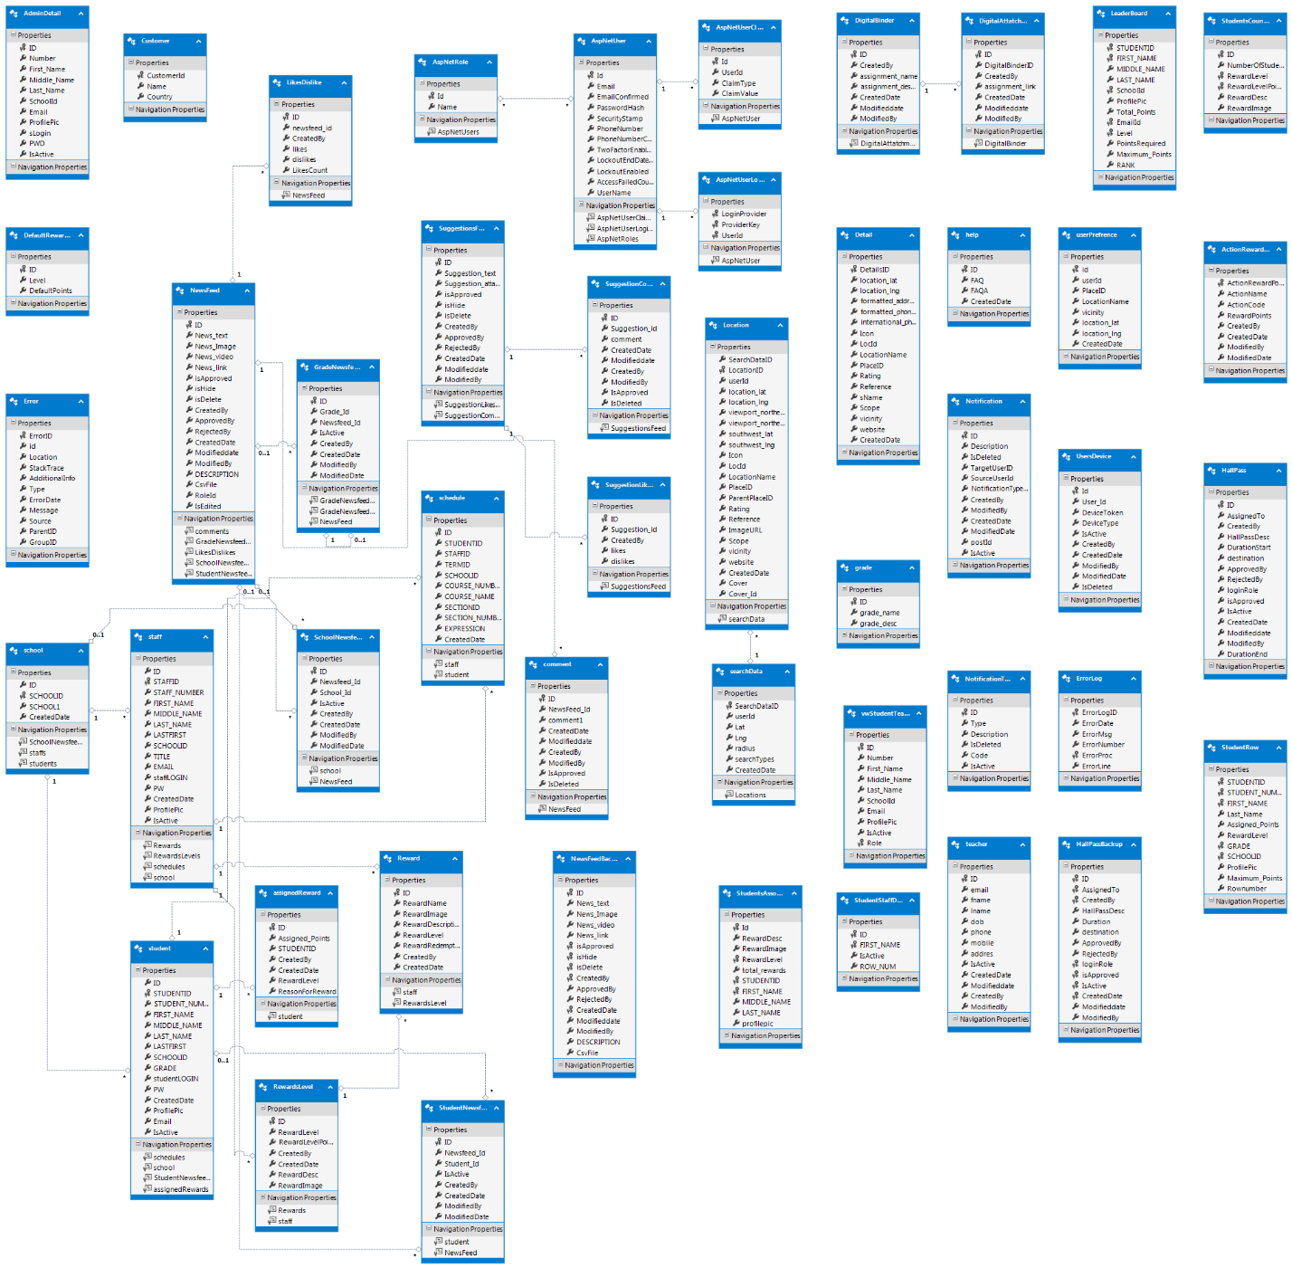

# 1. Mobile App:

## Logging in:

To log in to the Cincinnati Public Schools mobile app as a student or teacher, the following steps are to be performed:

* Click on the **Student** or **Teacher** button from the log in screen.
* After selecting the appropriate button, you will be redirected to the Sign in with Google screen.
* Click the Sign in with Google button. You will be redirected to the ‘Choose an Account’ screen.
* On this screen, select an existing account or create a new account. Provide the password when prompted.
* After entering a valid password, you will be redirected to the Home page of the CPS app.

|  |  |  |
| --- | --- | --- |
|  |  |  |

## Themes

After logging In, based on the school type users (either teachers or students) belongs to same school will get unique theme, which is applicable for entire application like side nav bar color, tool bar color, text view color etc.

|  |  |  |
| --- | --- | --- |
|  |  |  |

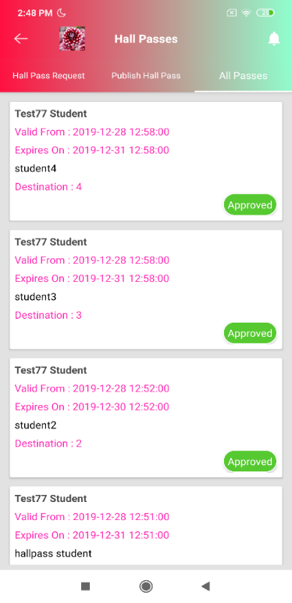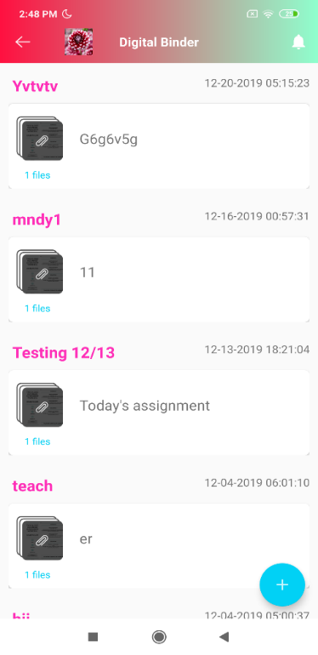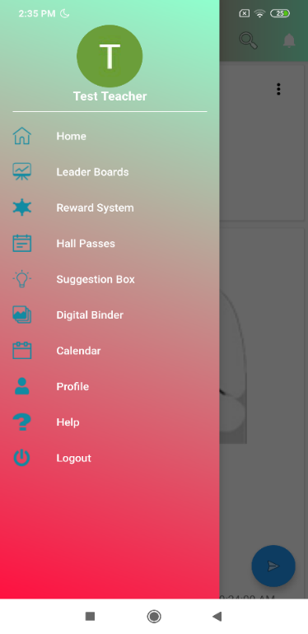

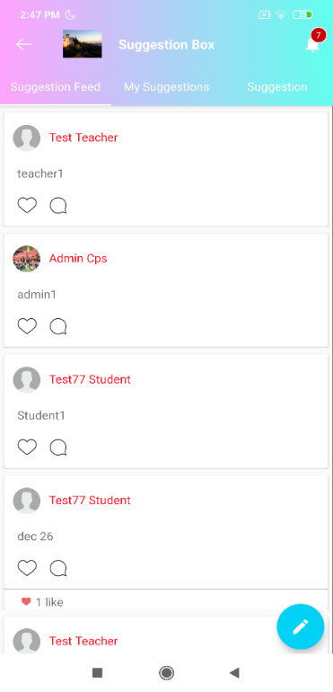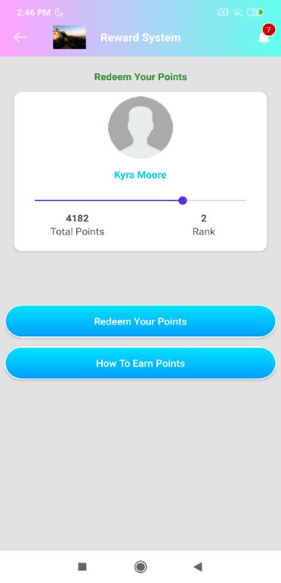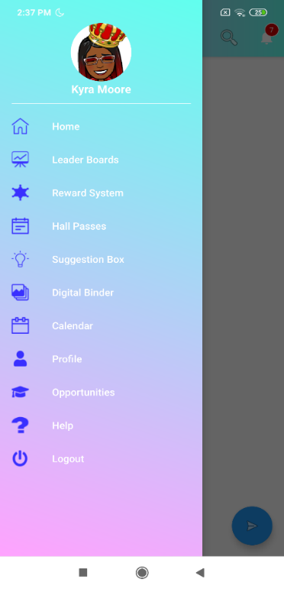

## Student Login

### Home Page:

When you log in as a Student, you can view the News Feeds posted by the students, teachers or admin users on your Home page. A student can post in the application, which include text, pictures, videos . You can also like posts, comment on posts, edit your post and delete your post . While adding news feed, a student can tag events which are added in the calendar, and student can edit or delete the comments on the post.

**Note:** There are certain rules and regulations for a student while posting a new post or commenting on an existing post. A student cannot post any objectionable pictures, videos and all the posts made by the students needs to be approved by an approver before being posted on the app. An approver can approve or reject a students’ posts.

|  |  |  |
| --- | --- | --- |
| Newsfeed | Create Newsfeed | Delete Newsfeed |

|  |  |  |
| --- | --- | --- |
| Comments | Edit Newsfeed | Tag event |

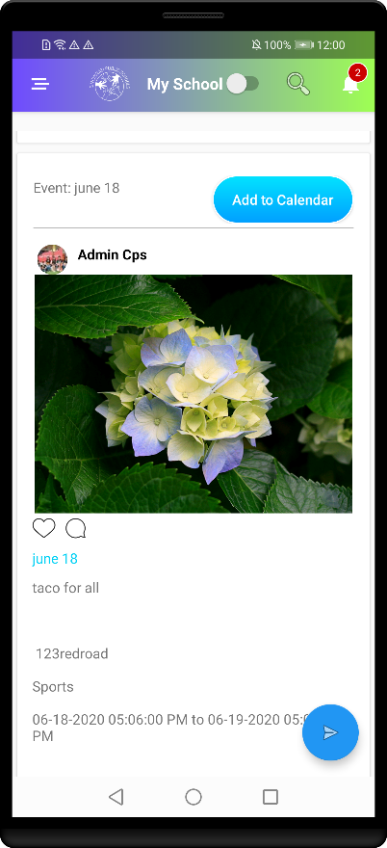

Add to Calendar

### Search:

Students can search for information in the app based on certain key words. There is a **Search** text box available at the top of the Home page. They can type in their keyword and the search result will be displayed below the **Search** text box based on the keyword typed.

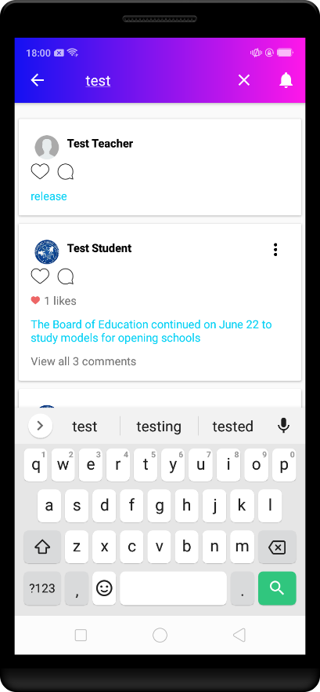

**My School:**

On enabling the “My option”, it displays the newsfeed related to that specific school only. By default, it is in disable mode displays newsfeeds of all the schools.

**Note:** If the **My School** toggle button is enabled after logging in, then you can view only the newsfeed pertaining to your own school and if the toggle button is disabled, you can view the all newsfeeds students of all the schools.

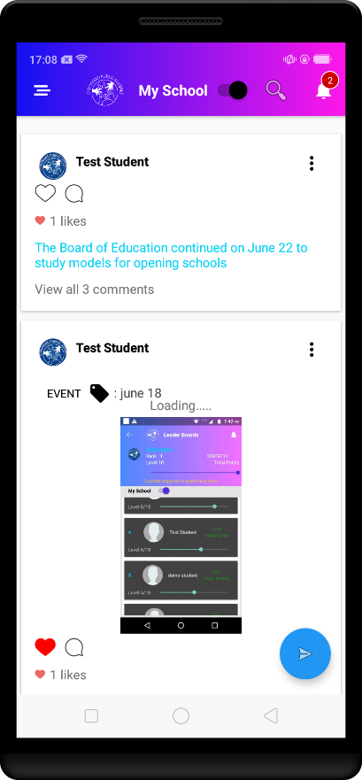

### Notifications:

The Notification page displays all the notifications including likes, comments made on your post, notifications when the hall pass is approved, etc. This page will display all the updates related to the students. You can click on any notification to access the details of a notification.

|  |  |
| --- | --- |
| Notifications | Notification view |

### Menu:

There is a **Menu** icon displayed at the top left corner of the Home page. You can click on this icon to view the list of menu options available from which you can select the menu you want and navigate to that page.

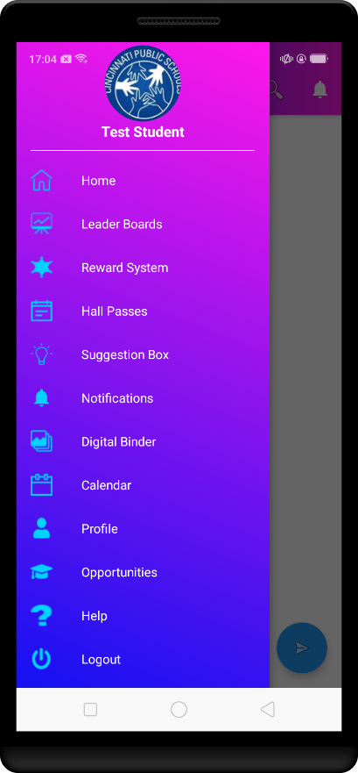

### LeaderBoards:

The Leaderboards page displays the details of the logged in student. This page displays details including rank, points, levels , along with the number of points required to reach the next levels. You can filter these details by clicking the **My School** toggle button.

**Note:** If the **My School** toggle button is enabled after logging in, then you can view only the details of the students belongs to your own school and if the toggle button is disabled, you can view the details of the students of all the schools.

|  |  |
| --- | --- |
| Leader Boards- all | Leader Boards – only school |

### **Rewards System**:

The Rewards System page displays the details of the logged in student including total points and rank. This page contains two buttons **Redeem my Points** and **How to Earn Points**. You can click the **Redeem my Points** button to redeemyour reward points. You can click the **How to Earn Points** button to get help on how to earn points.

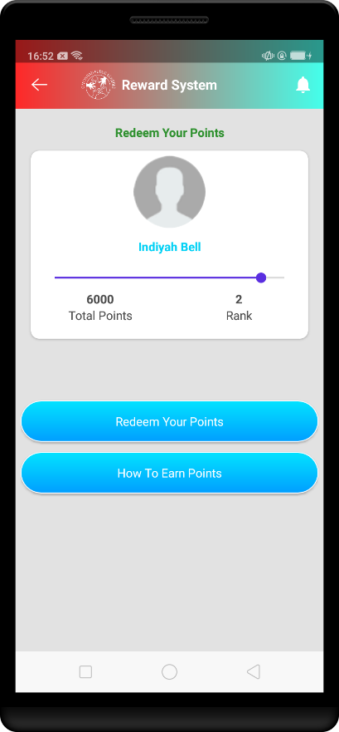

### Hall Passes:

The Hall Passes page consist of two tabs. They are **Request a hall pass** tab which displays all the hall pass requests along with the status of the respective hall pass and the **My Passes** tab which displays all the hall passes requested by the logged in user along with details including name, valid from(validity date), expires on(expiry date), description, destination, approved by.

#### Adding a new Hall Pass:

* You can add new a hall pass by clicking the **Add Hall Pass** button displayed at the bottom right corner of the **Request a hall pass** screen.
* You will be redirected to the Add Pass screen after clicking on this button. On this screen, you need to fill in information such as requesting teacher’s name, reason, destination, start date time, end date time etc.
* Then click the **Submit** button at the bottom of the screen. After clicking this button, a hall pass request will be generated and the selected teacher will get a notification asking for either the approval or rejection of that hall pass.

|  |  |
| --- | --- |
| Hall Passes | My Passes |
| Add Hall Passes | View Hall Pass |

### Suggestion Box:

The Suggestion Box page for students has three tabs; **Suggestion Feed**, **My Suggestions**, and **Suggestion**. The **Suggestion Feed** tab displays the suggestions of all the students logged in to the app. You can like or comment on those suggestions, and student can edit or delete his own suggestions. The **My Suggestions** tab displays the suggestions posted by you -the logged in student. It also displays the likes and comments on the respective suggestion selected by you. Student can also edit or delete the suggestion comments which have been posted by him. The **Suggestion** tab contains your suggestions, along with the status of the suggestions such as approved, pending or rejected.

#### Adding a New Suggestion:

* You can add a new suggestion by clicking **Add** button on the **Suggestion** tab.
* You will be redirected to the **Create Suggestion** page where you can provide your suggestion and post it by clicking the **Post** button.

|  |  |  |
| --- | --- | --- |
| Suggestion Box | My Suggestion | Suggestion |

|  |  |
| --- | --- |
| Comments | Create Suggestion |

### Digital Binder:

The **Digital Binder** page displays all the assignments of a student. Students can add a new assignment from this page and can edit the assignment. Whenever an assignment is added, it will be automatically saved into the google drive of the student’s signed in account.

#### Adding a New Assignment:

Click the **Add** button. You will be redirected to the **New Assignment** page. On this page, specify the assignment name and description, attach media including pictures and click the **Submit** button.

|  |  |
| --- | --- |
| Digital Binder | Add new assignment |
| Edit Assignment | view |

### Calendar:

It contains the view of the Calendar of the user’s signed in google account, which displays the events added by an admin, student, teacher or any another authorized user. A student can also add, edit and delete the events.

If you long press on date or if you click the button circled in the following diagram, it will display a dialog to create a new event. On the selected date, if you click on the already existing events, you can view the details, and student can edit and delete the event as well.

|  |  |  |
| --- | --- | --- |
|  |  |  |

|  |  |  |
| --- | --- | --- |
| view | Add to calendar | Add/Edit Event |

### **Profile**:

The **Profile** page contains total three Tabs: **About, My Profile, Opportunities**.

The **About** tab displays the school details of the student logged in to the app. The **My Profile** tab contains the details of the student logged in to the app. under My Profile tab student can update his/her information and student can attach document and can download the document provided by him/her. The **Opportunities** tab contains the list of opportunities applied by a student along with the status - Applied, Selected and Denied.

|  |  |  |
| --- | --- | --- |
| Profile | Opportunities | About |

### **Opportunities**:

The **Opportunities** page contains two tabs as **All Opportunities** and **My Opportunities**.

The **All Opportunities** tab contains all the opportunities available for the student logged in to the app. The **My Opportunities** tab contains the list of opportunities applied by the student, along with the status - Applied, Selected and Denied.

|  |  |  |
| --- | --- | --- |
| All Opportunities | My Opportunities | Opportunities details |

### Help:

The **Help** page contains the information about the different sections of the mobile application and the instructions to help the user to use the application, easily.

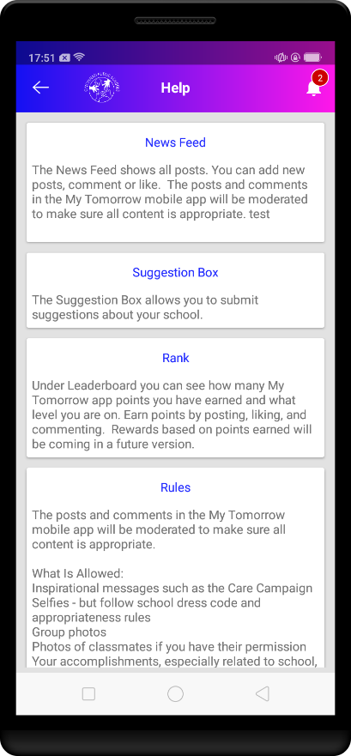

## Teacher Login

### Home:

When you log in as a Teacher, you can view the News Feeds posted by students, teachers or admin users. A teacher can post content in the application including text, pictures and videos. You can also like posts, comment on posts, edit your post, delete your post etc. While creating a news feed, the teacher can tag an event which the data will get from API.

**Note:** There are some rules and regulations for teachers while posting a new post or commenting on an existing post. They cannot post any objectionable text, pictures or videos. Their posts need to be approved by an approver before being published. An approver can approve or reject posts.

|  |  |  |
| --- | --- | --- |
| Newsfeed | Create Newsfeed | Delete Newsfeed |

|  |  |  |
| --- | --- | --- |
| Comments | Edit Newsfeed | Tag event |

**My School:**

On enabling the **“My Option”**, it will display the newsfeed related to that specific school only. By default, it is in a disabled mode and displays all the newsfeeds of all the schools.

**Note:** If the **My School** toggle button is enabled after logging in, you can view only the newsfeed pertaining to your own school and if the toggle button is disabled, you can view the newsfeeds of students of all the schools.



#### Search:

Teachers can search for information on the app based on certain key words. There is a **Search** text box available at the top of the Home page. They can type in their keyword and the search result will be displayed below the **Search** text box based on the keyword typed .



### Notifications:

The Notification page will display all the updates related to Teachers. and also various notifications including likes or comments made on your post, notifications when the hall pass is approved, among other notifications. You can click on any notification to access the details of that particular notification.

|  |  |
| --- | --- |
| Notifications | Notification view |

### Menu:

There is a **Menu** icon displayed at the top left corner of the Home page. You can click on this icon to view the list of menu options available from which you can select a menu and navigate to that page.

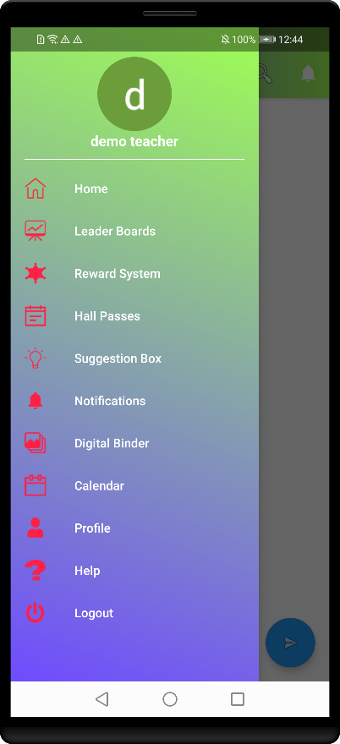

### LeaderBoards:

The **Leaderboards** page displays the details of the students, which include rank, points, levels. These details can be filtered by clicking the **My School** toggle button.

**Note:** If the **My School** toggle button is enabled after logging in, then you can view only the details of the students belongs to your own school and if the toggle button is disabled, you can view the details of all the students of all the schools.

|  |  |
| --- | --- |
| All Students | Specific to school |

### Rewards System:

On this page, Teachers can assign rewards points to their students.

**Assigning Rewards:**

* Select the student from the **Select a Student** drop-down list
* Mention the number of points and the reason for assigning the rewards in the respective text boxes
* Click the **Submit** button.

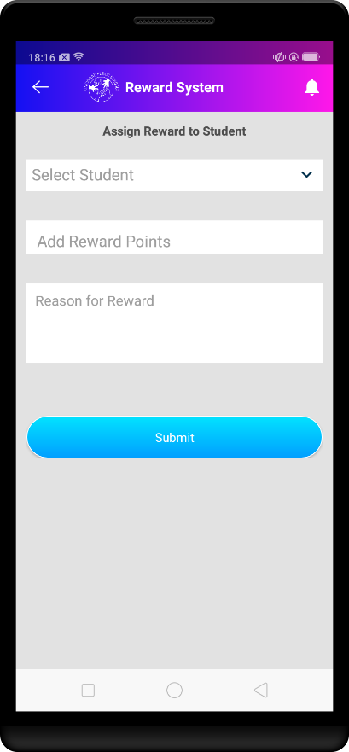

### Hall Passes:

The Hall Passes page contains three tabs. The first tab is the **Hall Pass Request** tab, which displays all the hall pass requests along with information such as description, destination, valid from(validity), expire on(expiry) . You can approve or reject a hall pass by clicking on the **Approve** or the **Reject** button.

The second tab is the **Publish Hall Pass** tab**.** You canpublish new hall passes for students. You need to specify information which include student name, reason, destination, start date time, and end date time.

**Note:** You cannot choose a past date range for the hall passes. You need to always choose a future date range

The third tab is the **All Passes** tabwhich displays all the hall passes that have a status associated with them.

|  |  |  |
| --- | --- | --- |
|  |  |  |

### Suggestion Box:

The **Suggestion Box** page for teachers displays the suggestions posted by the students logged in to the app. You can like or comment on those suggestions. You can edit or delete your own suggestion and you can add a new suggestion. Teacher can also edit or delete the suggestion comments which have been posted by him/her.

#### Adding a New Suggestion:

* You can add a new suggestion by clicking the **Add** button.
* You will be redirected to the **Create Suggestion** page where you can describe your suggestion and post it by clicking the **Post** button.

|  |  |
| --- | --- |
|  |  |

### Digital Binder:

The Digital Binder page displays all the assignments of those students assigned to you. You can add a new assignment from this page and can edit the assignment. Whenever an assignment is added, it will be automatically saved into the google drive of the signed in google account.

#### Adding a New Assignment:

* Click the **Add** button.
* You will be redirected to the **New Assignment** page. On this page, specify the assignment name and description, attach media such as pictures and click the **Submit** button.

You can also edit the students’ assignments and view their attachments as shown below.

|  |  |
| --- | --- |
| Digital Binder | Add new assignment |
| Edit Assignment |  |

### Calendar:

It contains the view of the Calendar of signed in google account, which displays the events added by admin, or student or teacher or any another. Even students can add, edit and delete the events.

If you long press the date, it will show a dialog to create a new event or the selected date. and if you click on the already existing events then you can view the details and student can even edit and delete the event.

|  |  |  |
| --- | --- | --- |
|  |  |  |

|  |  |  |
| --- | --- | --- |
| view | Add to calendar | Add/Edit Event |

### **Profile**:

Profile page **About Teacher** - It shows the school details of the teacher logged in to the app.

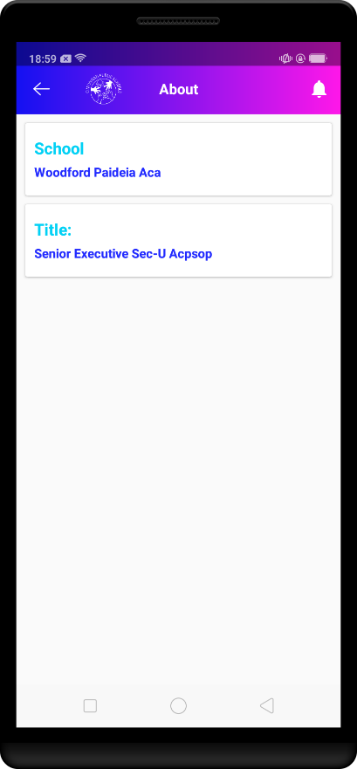

### Help:

The Help page contains the information about the different sections of the application and the instructions to help a user to use the application easily.

